**INT246 – SOFT COMPUTING**

**ASSIGNMENT REPORT**

Building Neural Network for Image Classification using CIFAR- 10 Data Set

**Group Members:** Mahadasu Gowtham Kishore, 11801832

Molla Baquar Abbas , 11804167

**Introduction:-**

**Image Classification**

* The classification problem is to categorize all the pixels of a digital image into one of the defined classes.
* Image classification is the most critical use case in digital image analysis.
* Image classification is an application of both supervised classification and unsupervised classification.
  + In supervised classification, we select samples for each target class. We train our [neural network](http://news.mit.edu/2017/explained-neural-networks-deep-learning-0414) on these target class samples and then classify new samples.
  + In unsupervised classification, we group the sample images into clusters of images having similar properties. Then, we classify each cluster into our intended classes.

### **About Image Classification Dataset**

CIFAR-10 is a very popular computer vision dataset. This dataset is well studied in many types of deep learning research for object recognition.

This dataset consists of 60,000 images divided into 10 target classes, with each category containing 6000 images of shape 32*32. This dataset contains images of low resolution (32*32), which allows researchers to try new algorithms. The 10 different classes of this dataset are:

1. Airplane
2. Car
3. Bird
4. Cat
5. Dog
6. Frog
7. Horse
8. Ship
9. Truck

CIFAR-10 dataset is already available in the datasets module of Keras. We do not need to download it; we can directly import it from keras.datasets.

**Steps :**

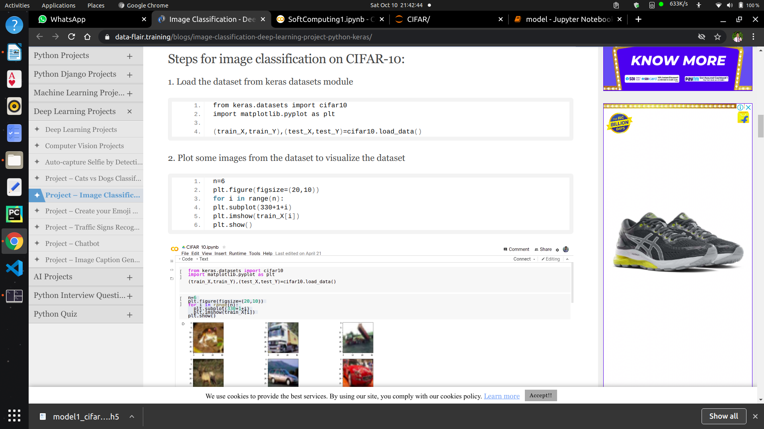

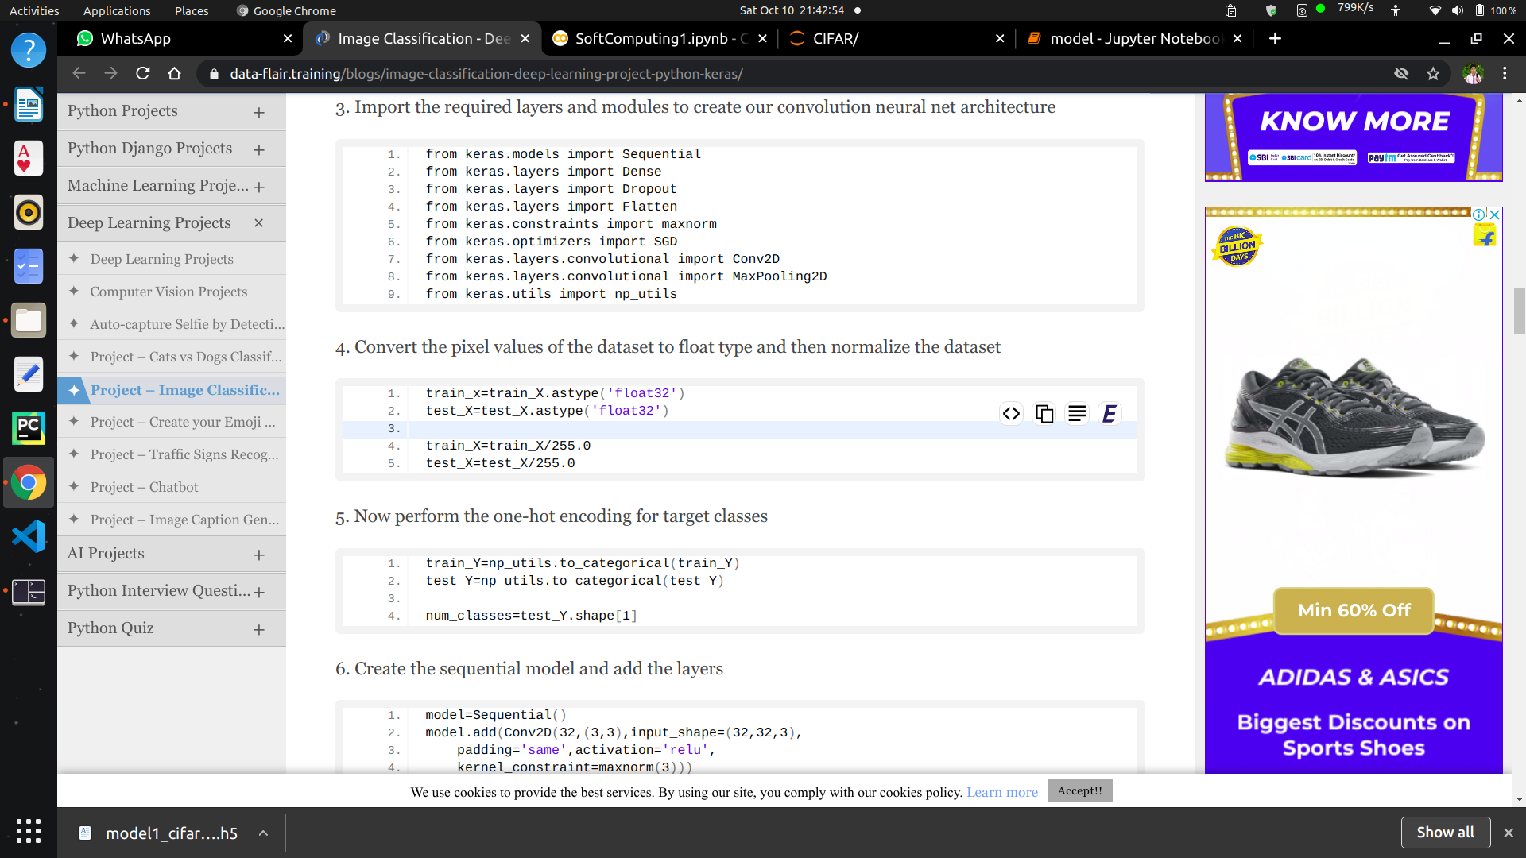

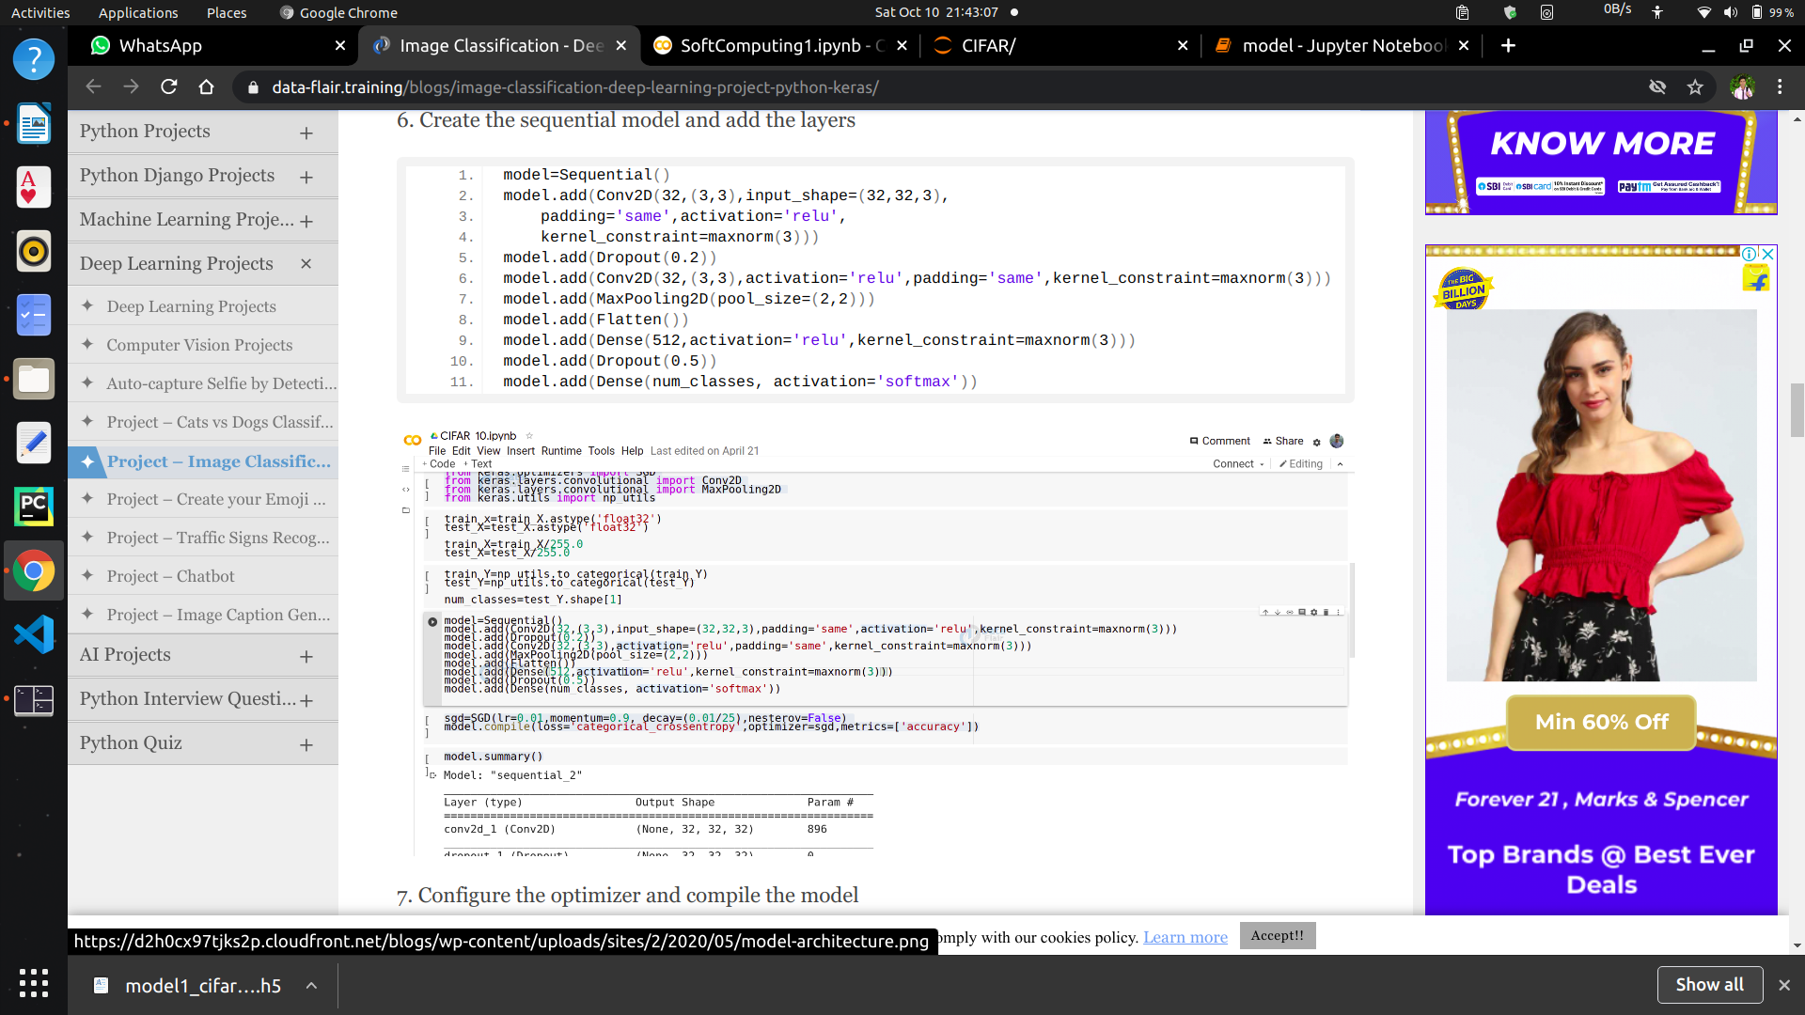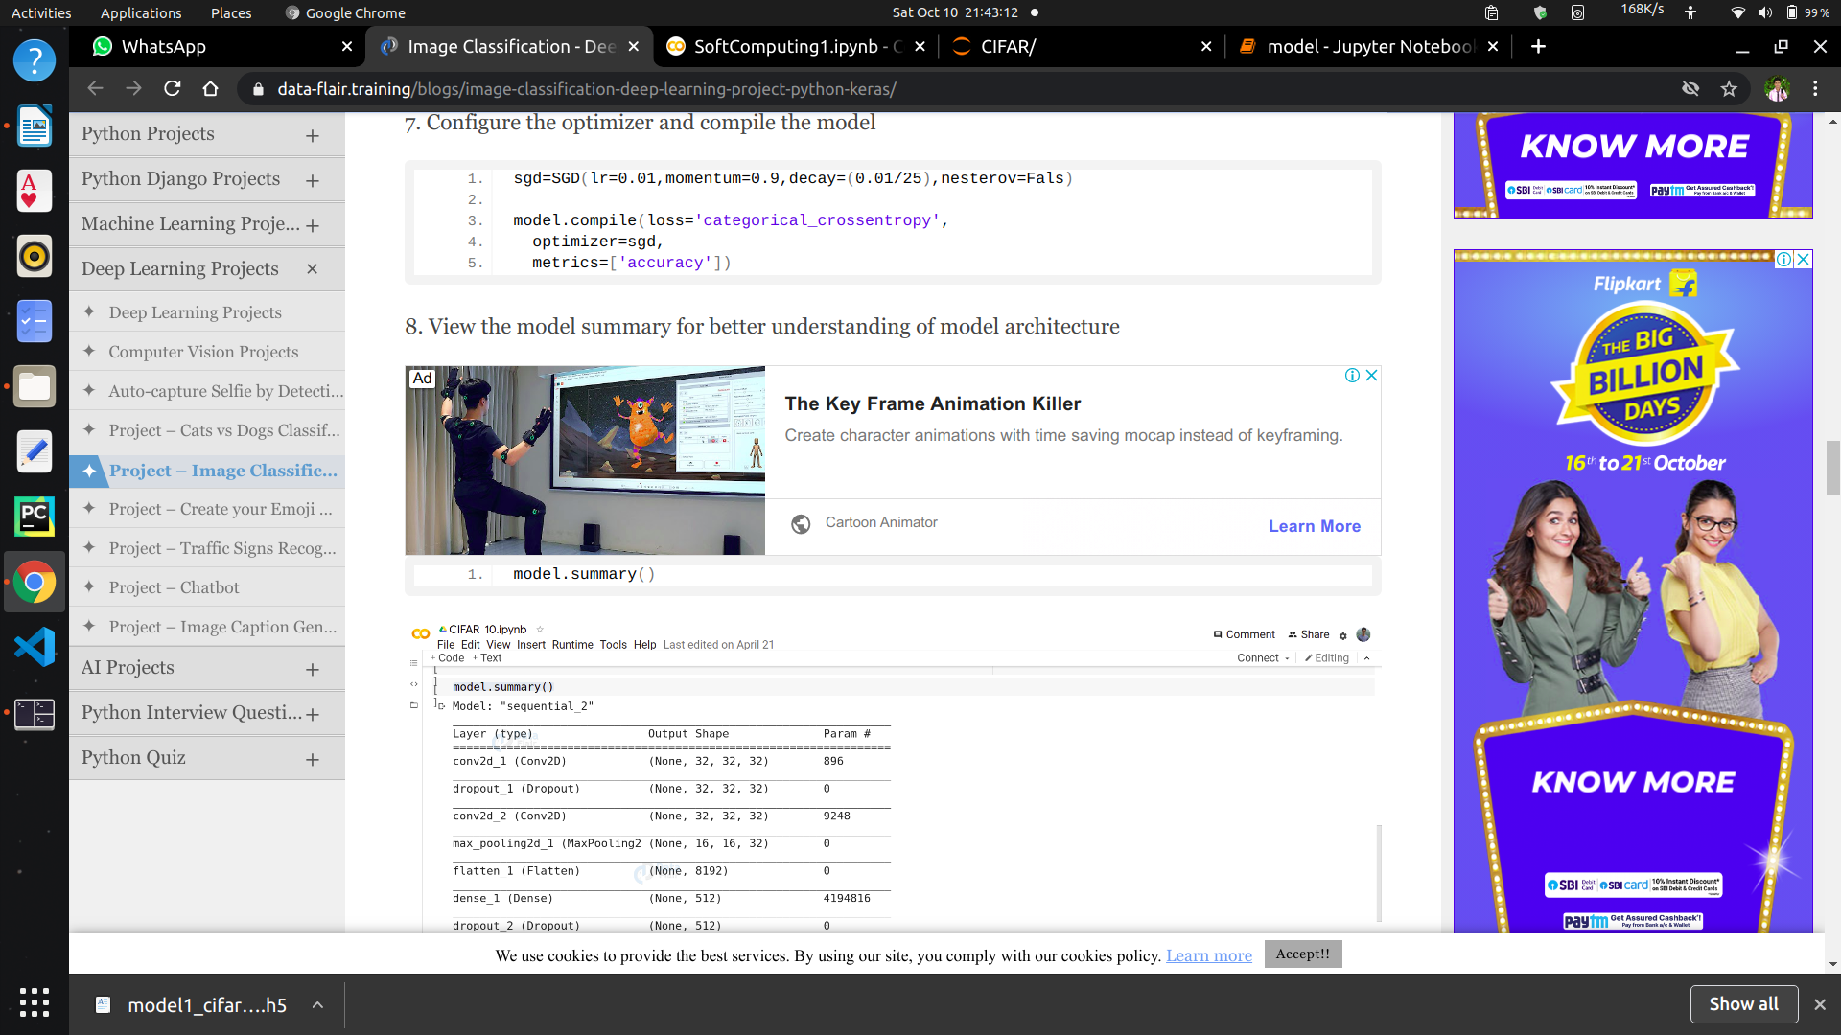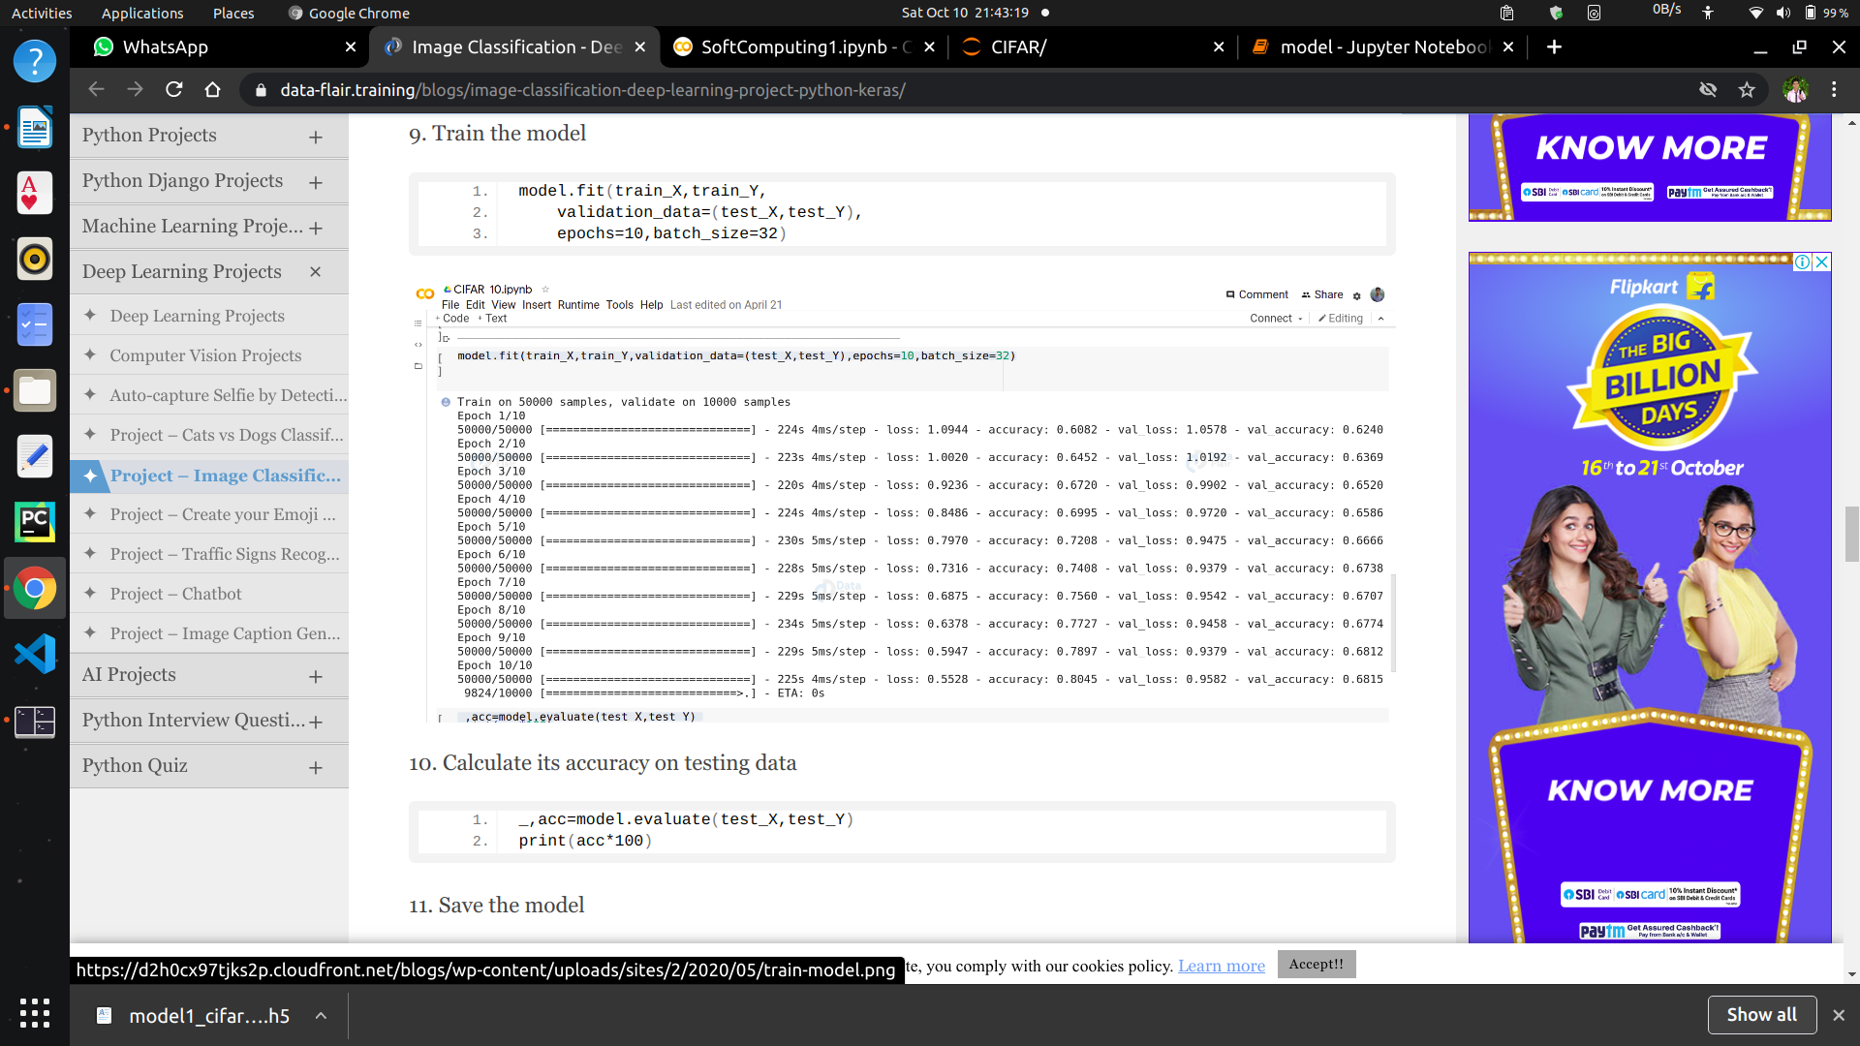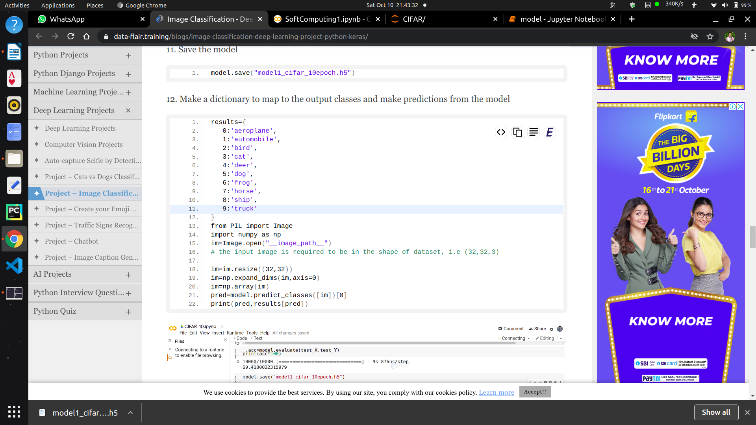

**GUI code Screenshot:**

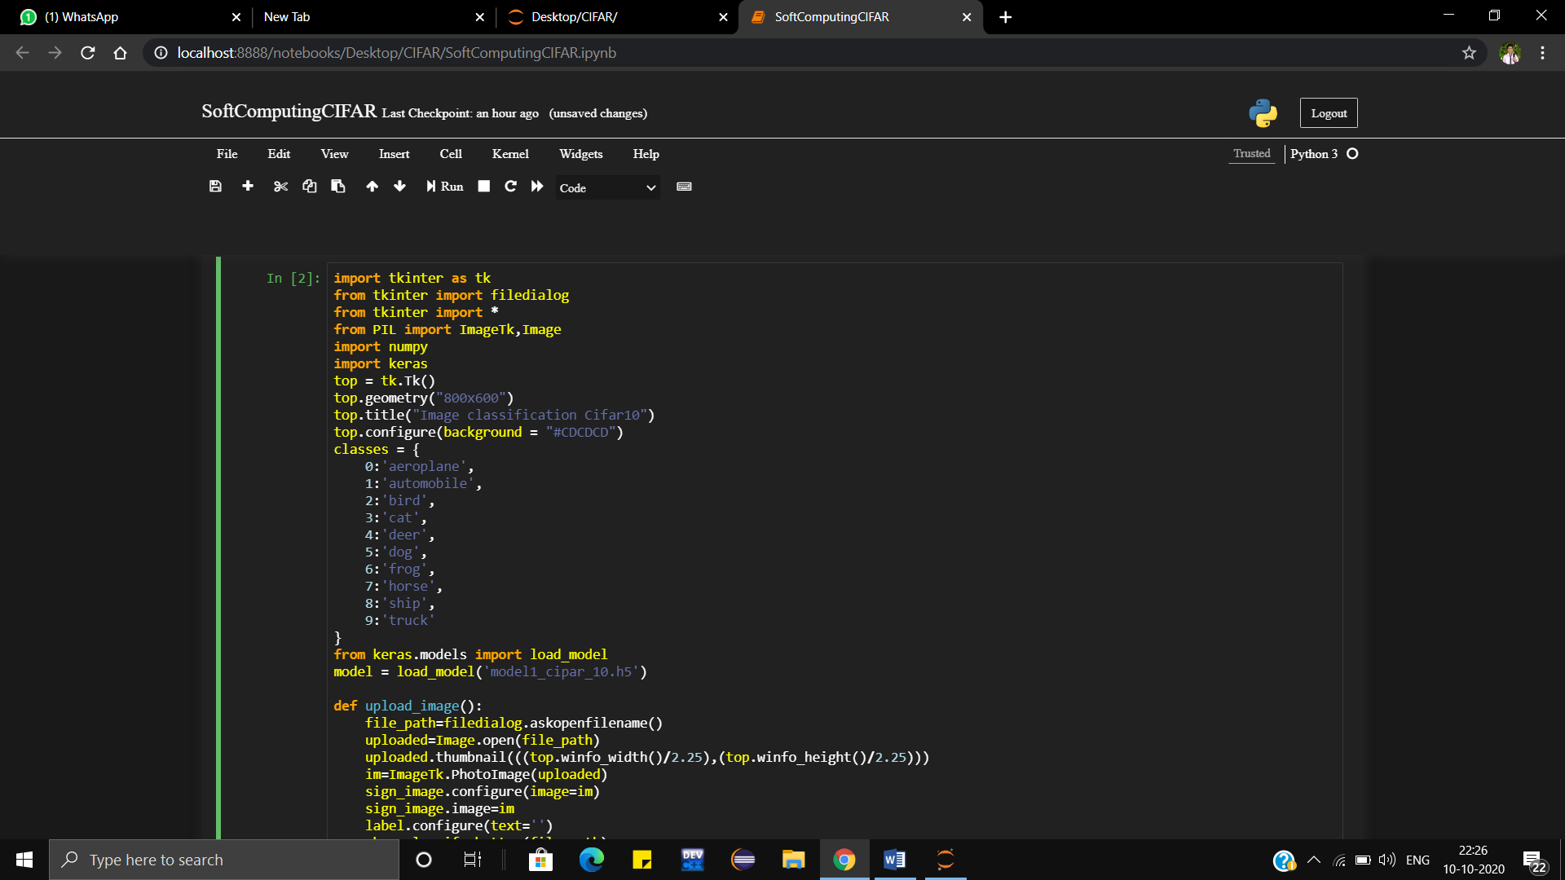

**OUPUT SCREENSHOTS:**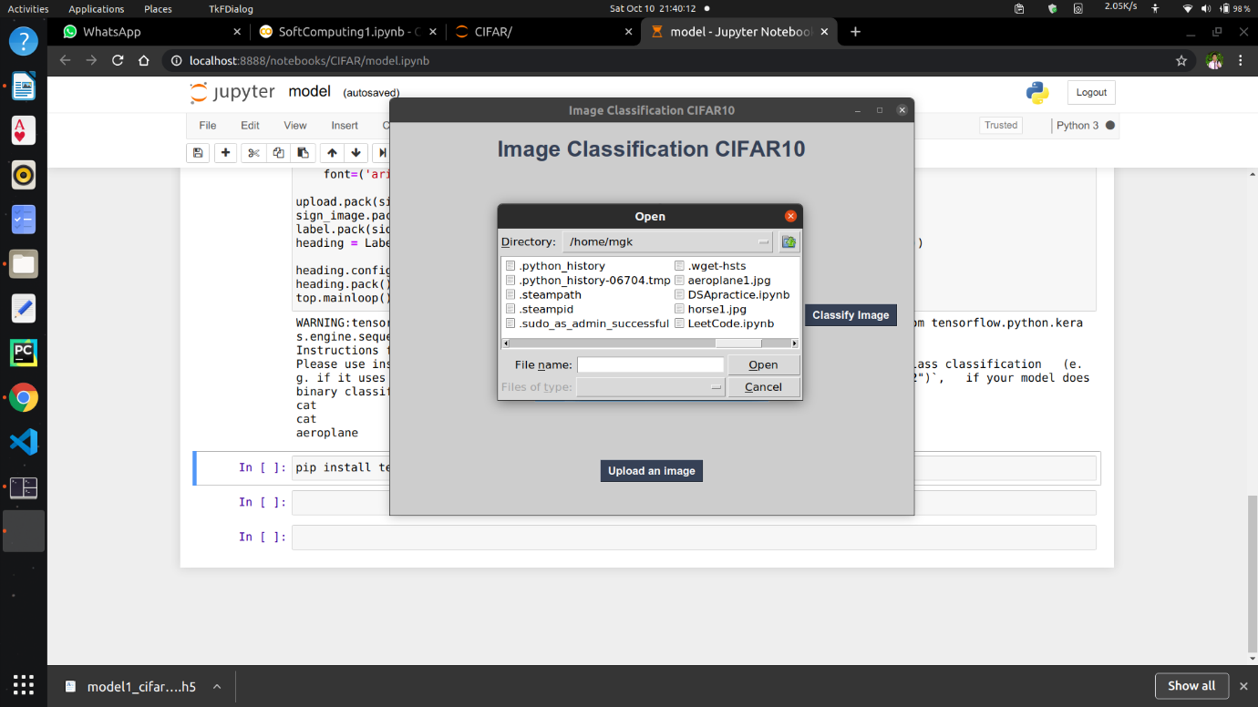

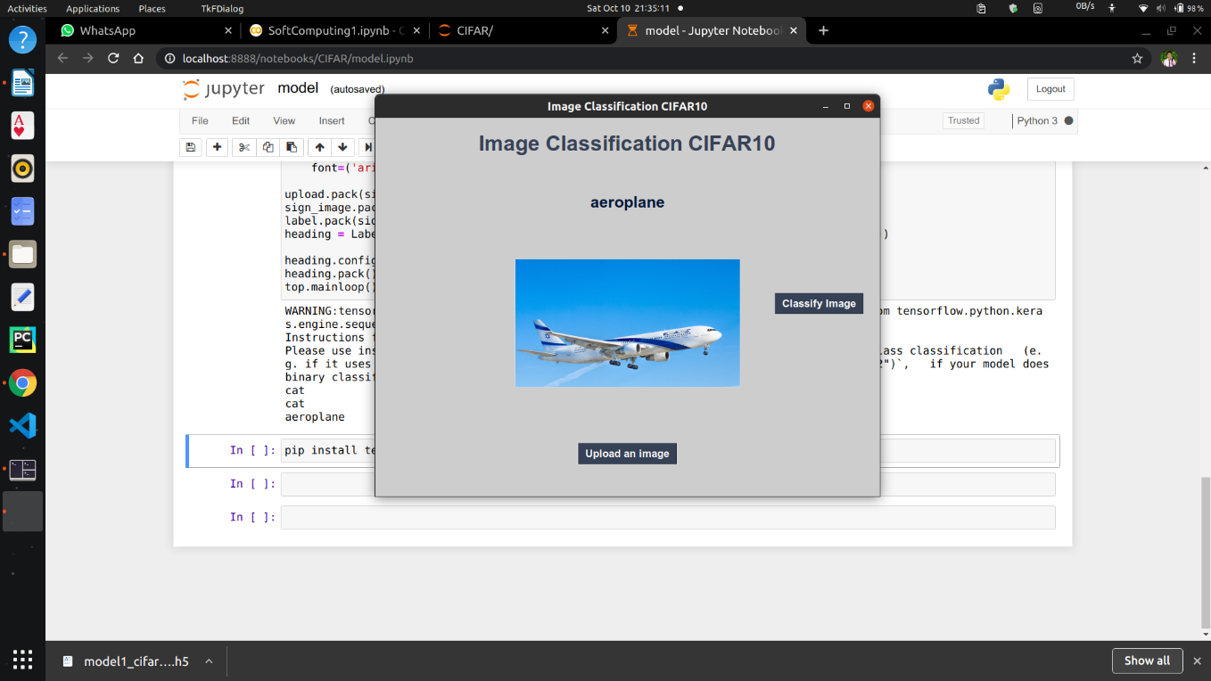

**GitHUB LINK:**

[**https://github.com/gowthamkishorem/SOFTCOMPUTINGASSIGNMENT/tree/main/CIFAR**](https://github.com/gowthamkishorem/SOFTCOMPUTINGASSIGNMENT/tree/main/CIFAR)

**GOOGLE COLAB CODE LINK:**

[**https://colab.research.google.com/drive/1Vt1jGXLp31HFwioRrvJXIX7wMCwjlKZl#scrollTo=Yo-Iagd5ambP**](https://colab.research.google.com/drive/1Vt1jGXLp31HFwioRrvJXIX7wMCwjlKZl%23scrollTo=Yo-Iagd5ambP)